**1. PRODUCT (PROBLEM STATEMENT)**

* **Short Description:** A Study Buddy app that connects students with peers or AI-based tutors to collaboratively study, share knowledge, and stay motivated.
* **Background:** Many students struggle with self-discipline, understanding complex topics, and finding study partners. Traditional learning resources like YouTube lack interactivity and personalized engagement.
* **Domain:** Education Technology (EdTech).
* **Scope:** The app will allow users to:

1. Find study partners for real-time or scheduled sessions.
2. Access AI tutors for instant help when no partner is available.
3. Track study progress and set goals.

* **Objectives:**
* Facilitate real-time study connections globally.
* Provide AI-based tutoring support.
* Enable personalized study tracking and gamified progress.

**2. BUSINESS REQUIREMENTS**

* **Business Opportunity:**
* **Problem:** Students feel isolated and unmotivated in self-learning environments.
* **Opportunity:** The app addresses the gap in interactive learning by combining human collaboration and AI assistance.
* **Competing Market:** Platforms like YouTube focus on passive learning, whereas this app is designed for active collaboration.
* **Business Objective and Success Criteria:**
* **Goal:** Achieve a user base of 50,000 students within the first 6 months.
* **Measure Success:** Positive user reviews, improved academic performance, and 80% user retention.
* **Customer or Market Needs:**

1. Students need personalized, interactive, and engaging study sessions.
2. Lack of easily accessible real-time peer-to-peer learning platforms.

* **Business Risks:**

1. Competition from existing platforms.
2. User reluctance to adopt a new app.
3. Ensuring AI responses are accurate and helpful.

**3. VISION OF THE SOLUTION**

* **Vision Statement:** To create a supportive global learning community where students can collaborate, gain insights, and achieve their academic goals interactively.
* **Major Features:**

1. Real-time matching with study partners.
2. AI-based tutoring for immediate assistance.
3. Gamified study progress tracking (e.g., badges and leaderboards).

* **Assumptions:**

1. Users have access to the internet.
2. Students are motivated to collaborate and learn.

* **Dependencies:**

1. Availability of third-party AI services for tutoring.
2. Adherence to educational data privacy laws.

**4. SCOPE AND LIMITATION**

* **Concept and Range:** A mobile app connecting students for real-time or scheduled study sessions, integrating AI support when human help isn't available.
* **Limitations:**

1. Cannot replace professional tutoring or in-depth educational platforms.
2. Success depends on user base activity and engagement.

* **Scope of Initial Release:**
* **Features:**  User matching, AI tutoring, and study progress tracking.
* **Workflow:**

1. User logs in.
2. Selects a topic or need.
3. Gets matched with a study buddy or AI tutor.

**5. USE CASE EXAMPLE**

### Describing the Use Cases

|  |  |
| --- | --- |
| **Name of Use-Case** | **Study Partner Matching** |
| **Identifier** | UC-1 |
| **Purpose** | To match a user with a compatible study partner. |
| **Priority** | High |
| **Pre-conditions** | User is registered and logged in. User has selected a topic to study. |
| **Post-conditions** | User is successfully matched with a partner or AI tutor. |

### Typical Course of Action

|  |  |  |
| --- | --- | --- |
| **S#** | **Actor Action** | **System Response** |
| 1 | User selects the topic and time availability. | System searches for compatible study partners. |
| 2 | User reviews the match. | System displays the matched study partner(s). |
| 3 | User accepts or rejects the match. | System initiates a chat or study session if accepted. |

### Alternate Course of Action

|  |  |  |
| --- | --- | --- |
| **S#** | **Actor Action** | **System Response** |
| 1 | No study partner is available. | System assigns an AI tutor to the user. |
| 2 | User does not prefer AI assistance. | System schedules a notification for the user when a match becomes available. |

### Use Cases Diagram

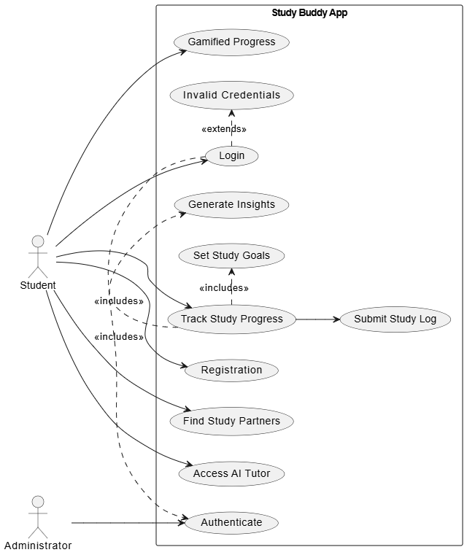

**PROJECT PROTOTYPE:**

